

Client: Tesla Science Center at Wardenclyffe
Date: 3.20.20
Facebook/LinkedIn/Instagram/Twitter - Social Media Analytics + Analysis

Twitter (February 19th to March 17th):

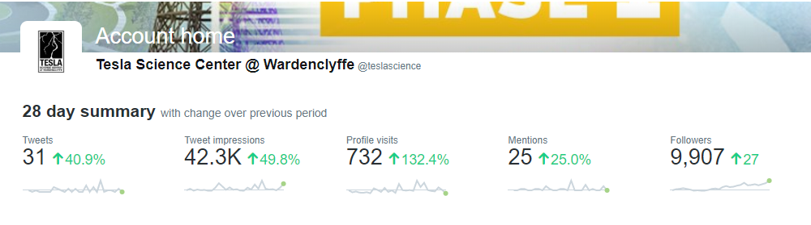
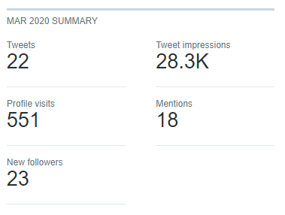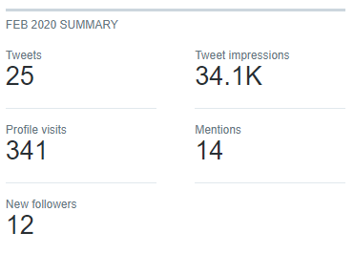
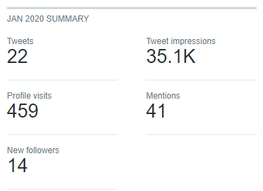

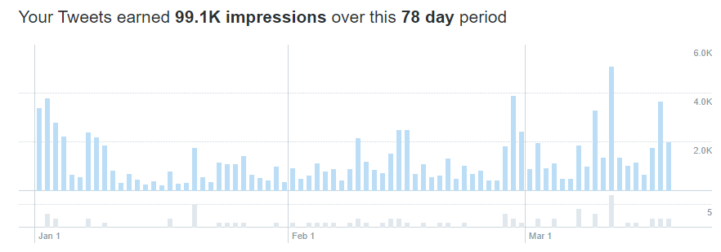

Top Tweets:
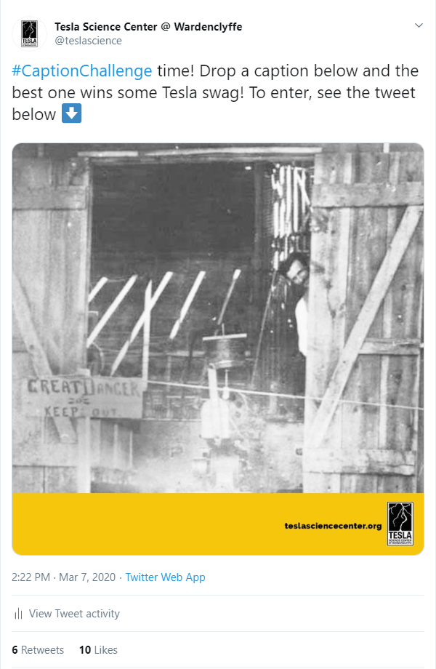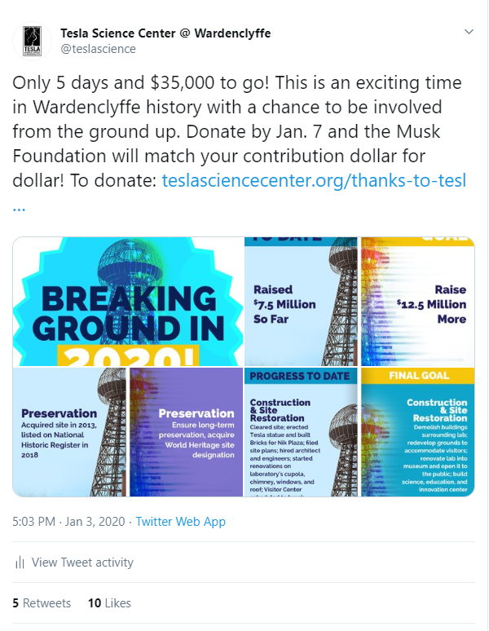

Analysis:
- We’ve gained 59 followers since the beginning of the year – in the past month, we’ve gained 27
- As we’ve tweeted content that spikes impressions, we’ve increased exponentially in profile visits. Profile visits trigger follows once people see the content on the page.
- To gain followers, we will need to tweet out more content that reflects our highest performing posts. The engagement rate on the top tweets since the beginning on the year are almost double most posts.
- 99K impressions is substantial for less than a 90-day period. This means when people are retweeting or liking our posts, they are showing up in the feed of their followers as content that may appeal to them.
- Once again, the content that does the best on Twitter for this account is both entertainment and education. That is what our followers expect from our page as that is what they interact and engage with the most.

Facebook (Feb. 19, 2020 – March 17, 2020):

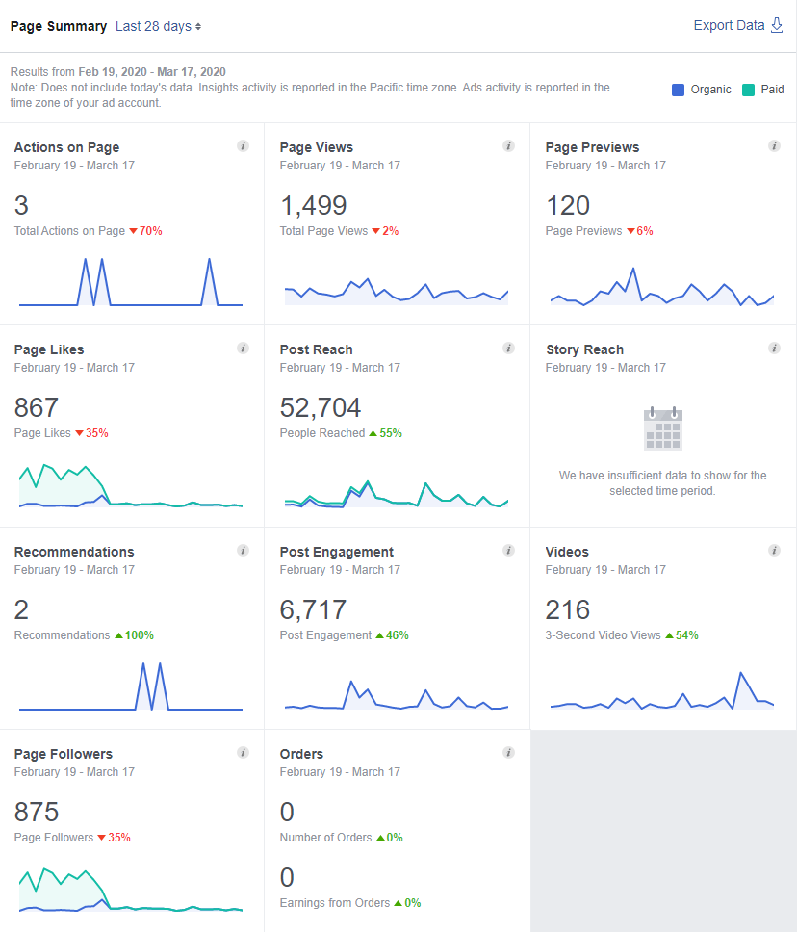
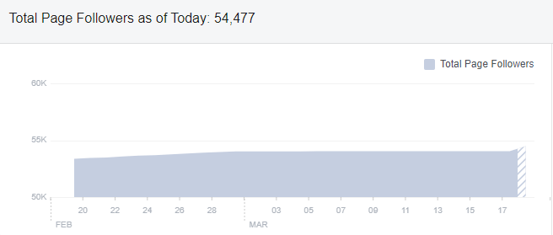
- Total increase of 1,114 followers (53,363 to 54,477)
- When someone follows your page, it means that your Facebook page posts will appear on their personal Facebook feed.
- People can follow a Page, even if they haven't liked it.
- Followers are a greater indicator of how many people are viewing our content

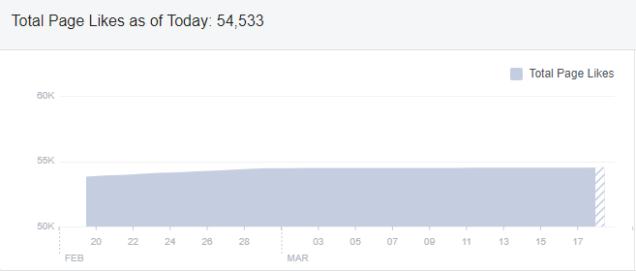
- Total increase of 711 page likes (53,822 to 54,533)
- When a new customer likes your page, the default setting is that they also follow your page.
- Page Likes are a greater indicator of the TSCW being recommended to people on feeds as their friends have liked the page and it could be a common interest.

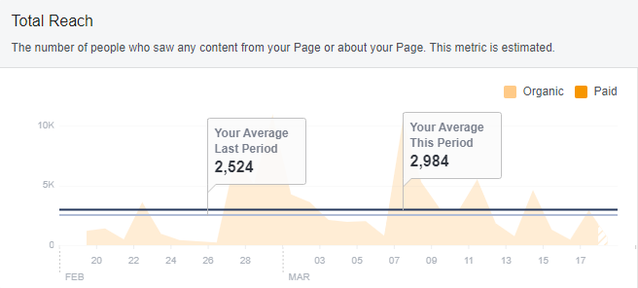
- Total average reach on content has gained 460 people for this time period (Feb 19 to March 17)
- Total reach is the number of unique people who saw your content. It affects every other metric you can track: engagement, likes, comments, clicks and negative feedback.
- This is directly correlated with shares and likes as that will show up on the feeds of our followers’ friends.

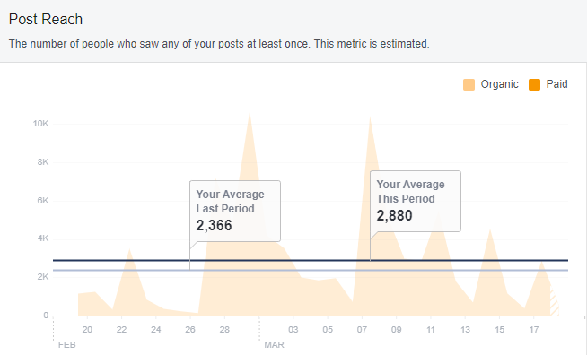
- Post reach has increased to 514 more people during this time period (Feb 19 to March 17)
- Post reach is the number of people who saw a specific post in their news feed. This is directly correlated with our page followers/active users.

Top Posts:
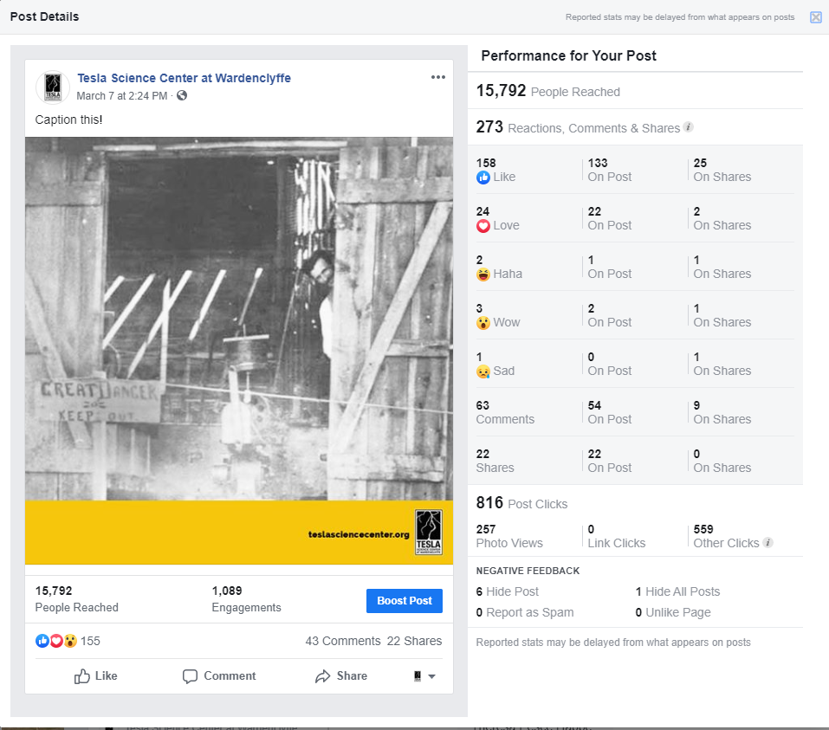
(March 7th, 2020)
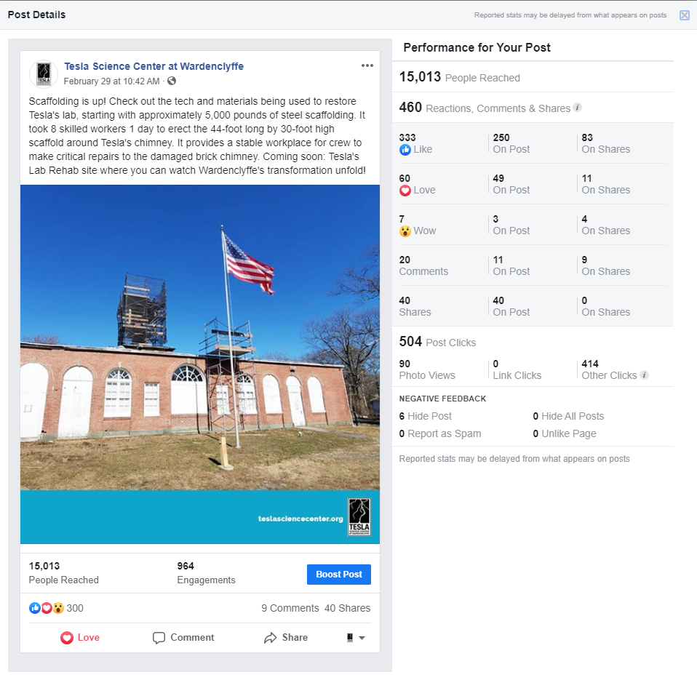
(February 29th, 2020)

- These were the top performing posts during this time period, in terms of reach, engagement, and impressions.
- This information tells us what kind of content our followers are not only interacting with, but the content they feel is best to share across their networks. This then leads to reach increasing exponentially, which is becoming as important as post likes.
- Using this information as a guide, we should format our content to be equal parts educational/informative (scaffolding going up) and entertaining (caption this, showing images of Tesla that are not popular, inviting engagement)

Analysis:
- Post reach and post engagement are reflective of the growth in followers over the last month. With a gain of over 1,000 followers and 700 page likes, as our content continues to be shared, that will not only increase reach, engagement, and shares – it will increase followers and page likes.

Instagram:

Follower Growth for Instagram (March 11 – March 18):

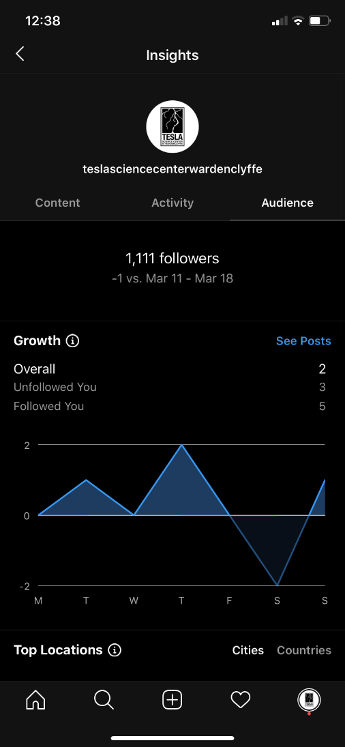
Follower Attribution by Post:

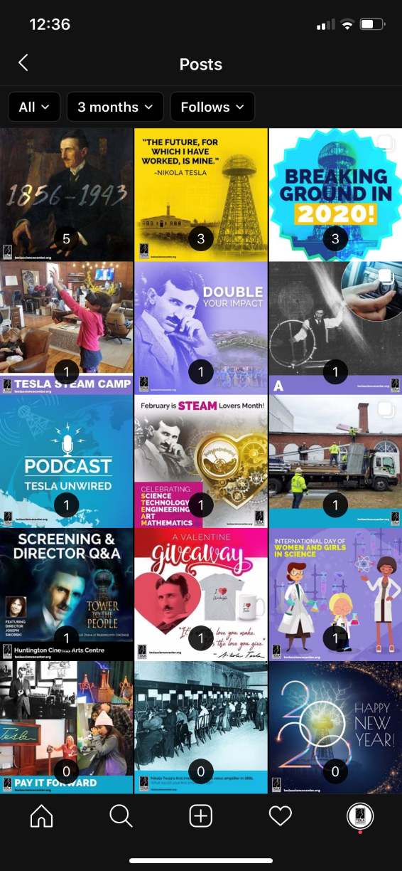

Impressions by Post:

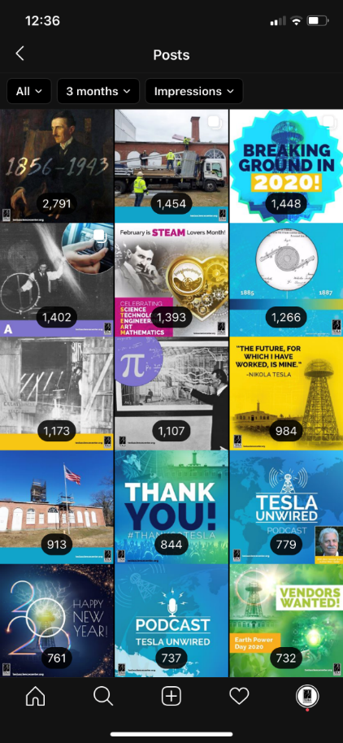
Post Reach By Post:

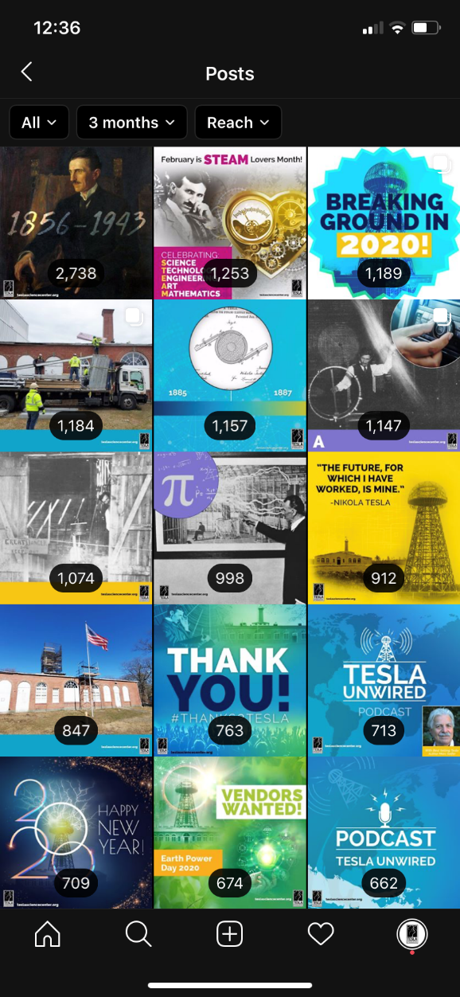

Age Range and Gender:

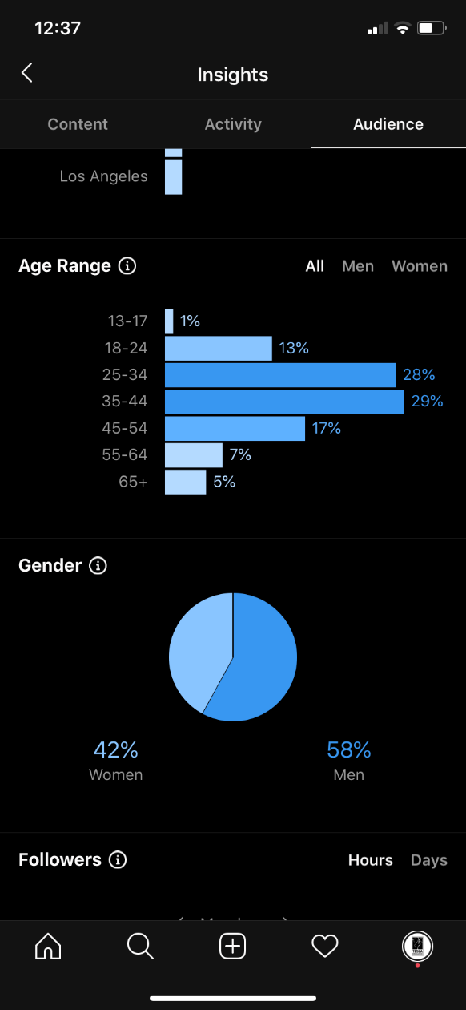

Discovery Insights:

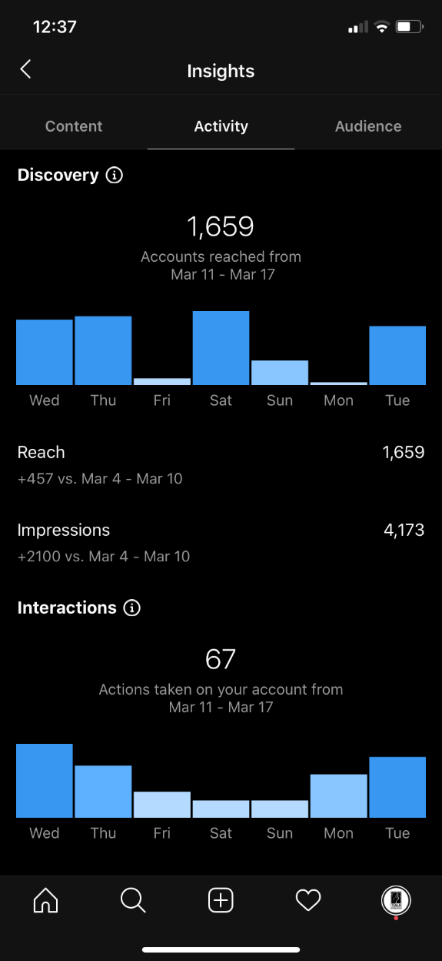

Top Posts for Instagram:

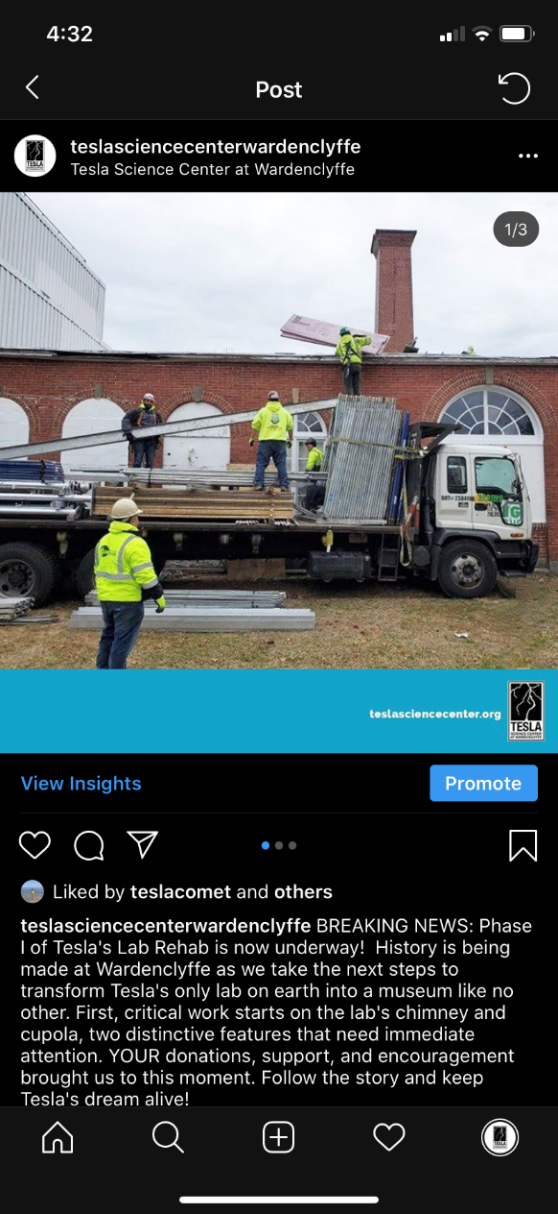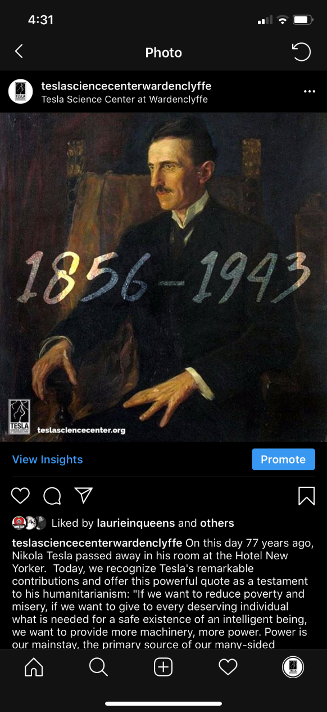

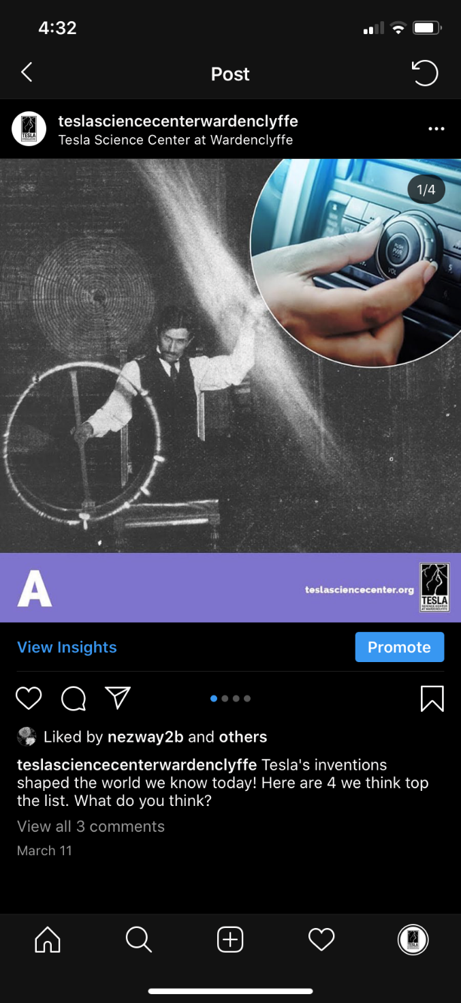

Analysis:
- Followers have not grown as we have desired. For the past week, we have gained 5 followers and lost 3. This is indicative of how we have been trending since the beginning of the year.
- For the most part, the posts that have the most reach have led to the most follows per post. This is attributed to hashtags, content, caption, engagement. We can use this information to influence future content.
- Reach is the total number of people who see your content.
- Impressions are the number of times your content is displayed, no matter if it was clicked or not.
- Once again reach is correlated to followers, while impressions are correlated to people who saw the post through hashtags along with followers and sharing.

LinkedIn:

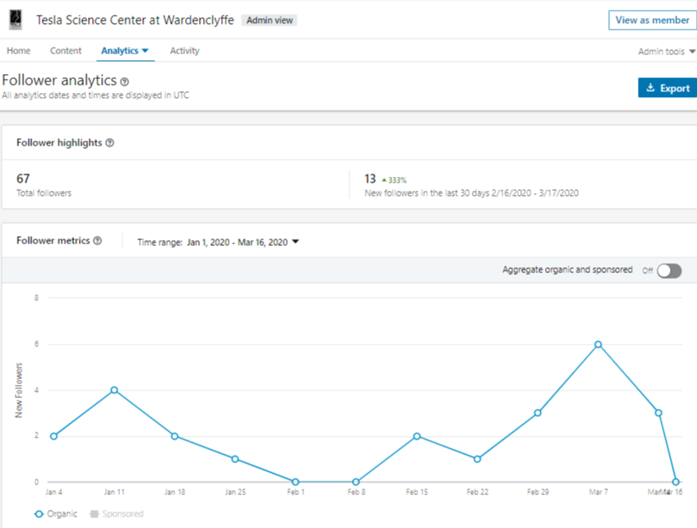

Top Posts:

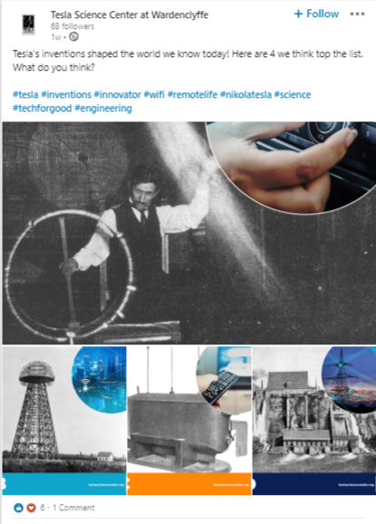

Analysis:
- We’re increasing at a large rate for the past month. This is an indicator that our content performs well for the LinkedIn community.
- We’ve grown 13 followers (a 333% increase) from 54 to 67 followers.
- The top performing posts had an engagement rate of 25.27% and 18.79% respectively – almost quadruple most posts.
- Information, educational, and a hint of entertainment is what works best on this platform.

